TUGAS AKHIR

MAKALAH LAPORAN PROGRAM

PEMROGRAMAN WEB II

“APLIKASI SISTEM PAKAR GEJALA PENYAKIT”



KELOMPOK :

ANGGA TRISNANDA (8020160016)

KELAS :

01PT5

DOSEN PENGAMPUH :

ABDUL RAHIM, S.KOM, M.KOM

TEKNIK INFORMATIKA

STIKOM DINAMIKA BANGSA

2019

LATAR BELAKANG

DATABASE

1. Table gejalas

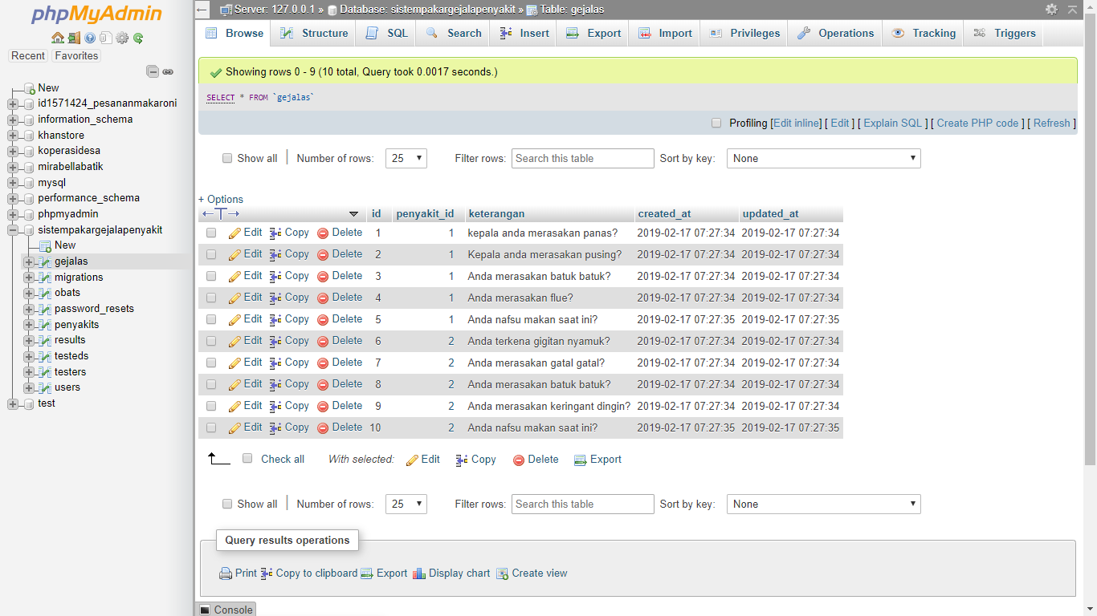

1. Table obats

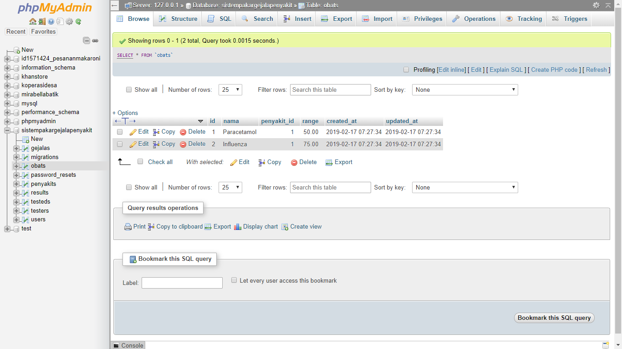

1. Table penyakits

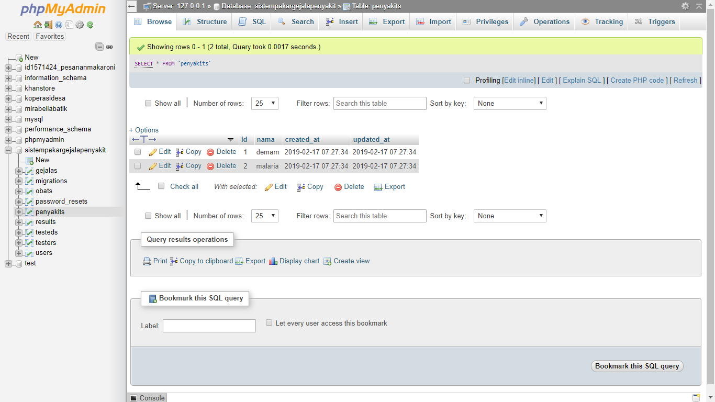

1. Table results

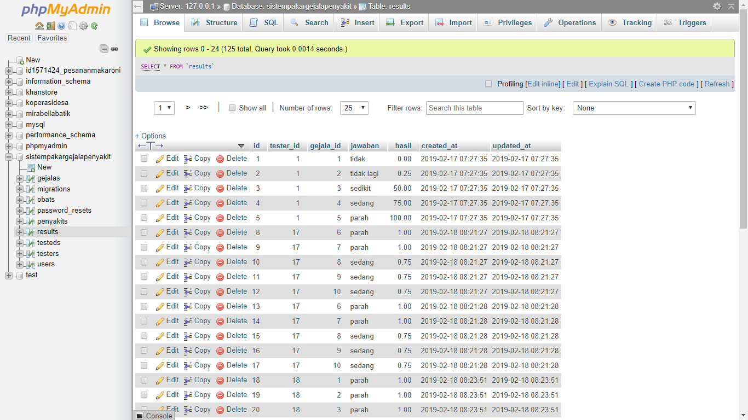

1. Table testeds

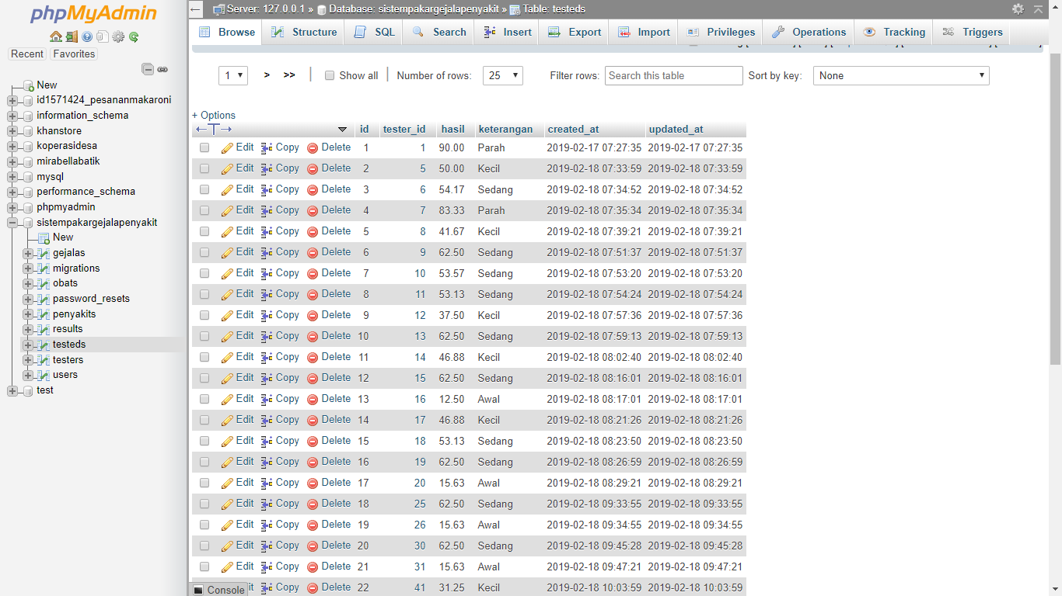

1. Table testers

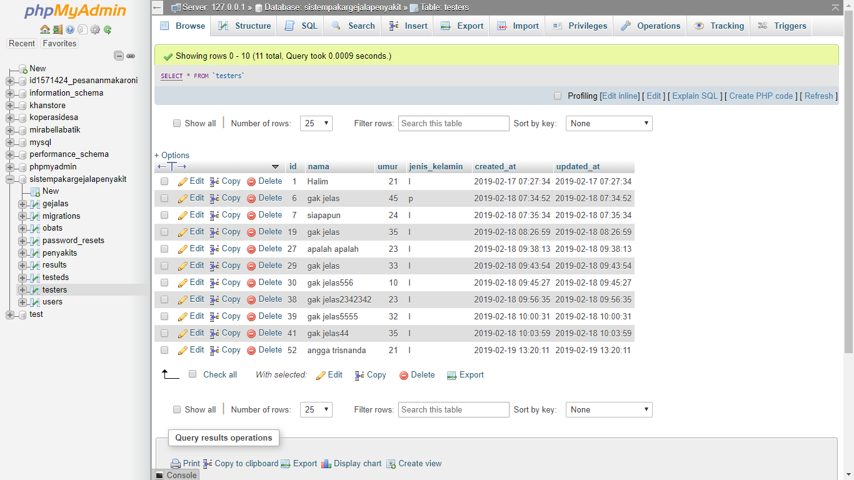

1. Table users

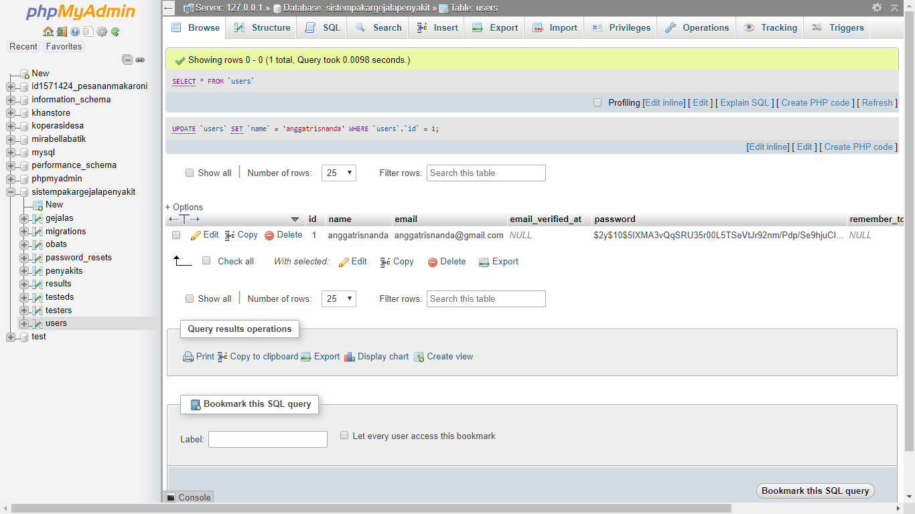

**Tabel Dengan Relasi Laravel**

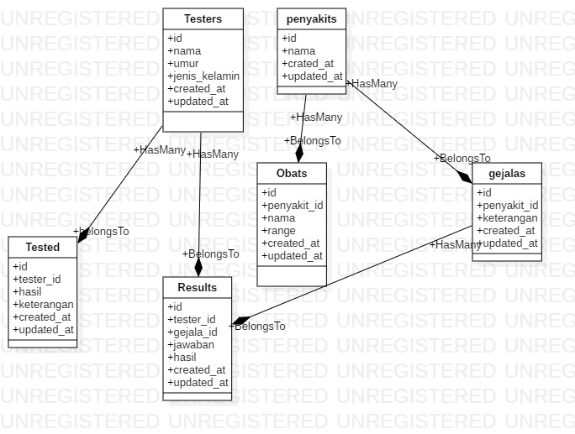

**Tampilan WEB**

**Halaman awal:**

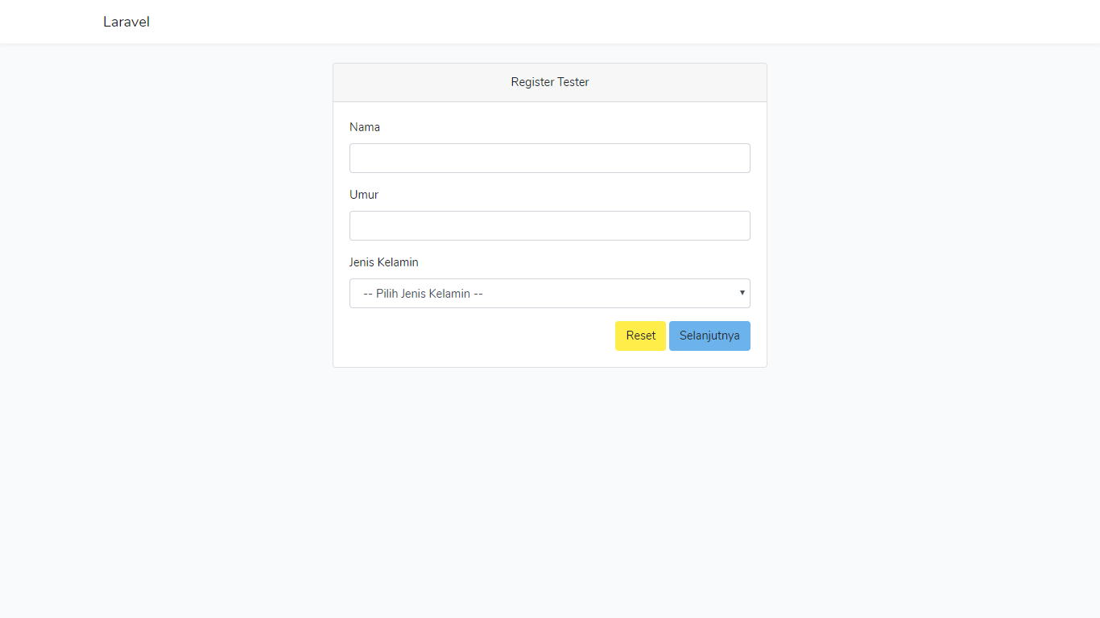

**Halaman awal jika salah memasukkan inputan:**

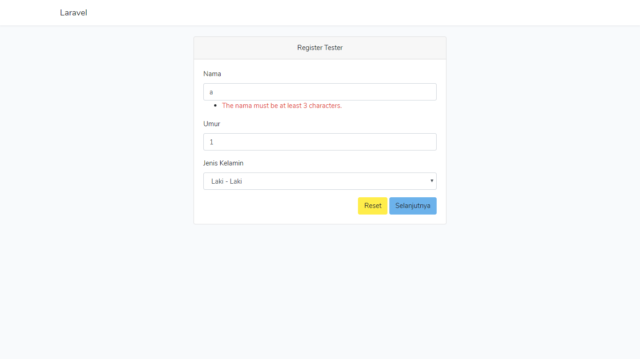

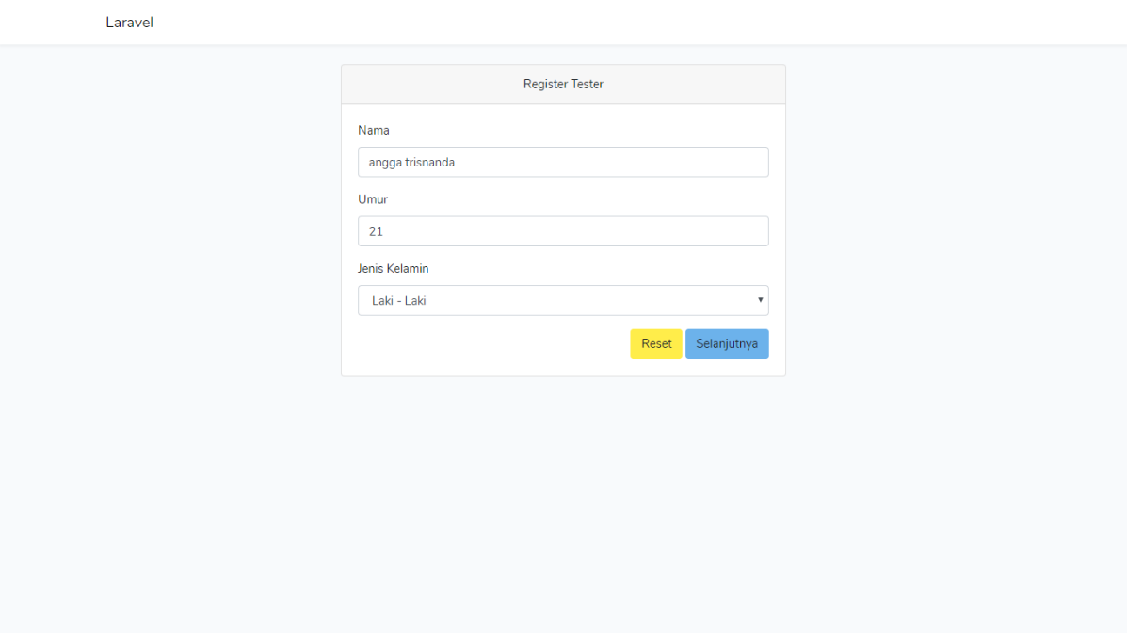**halaman awal jika data yang diinput benar**

**halaman awal jika data yang diinput harus direset (ulangi mengisi inputannya)**

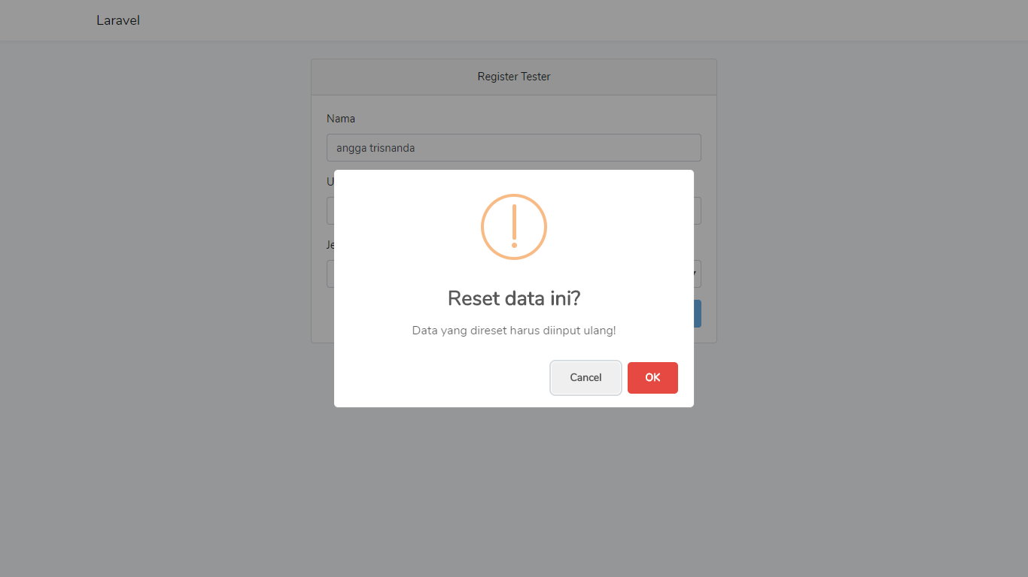

**Halaman pilih penyakit, setelah mengisi data tester:**

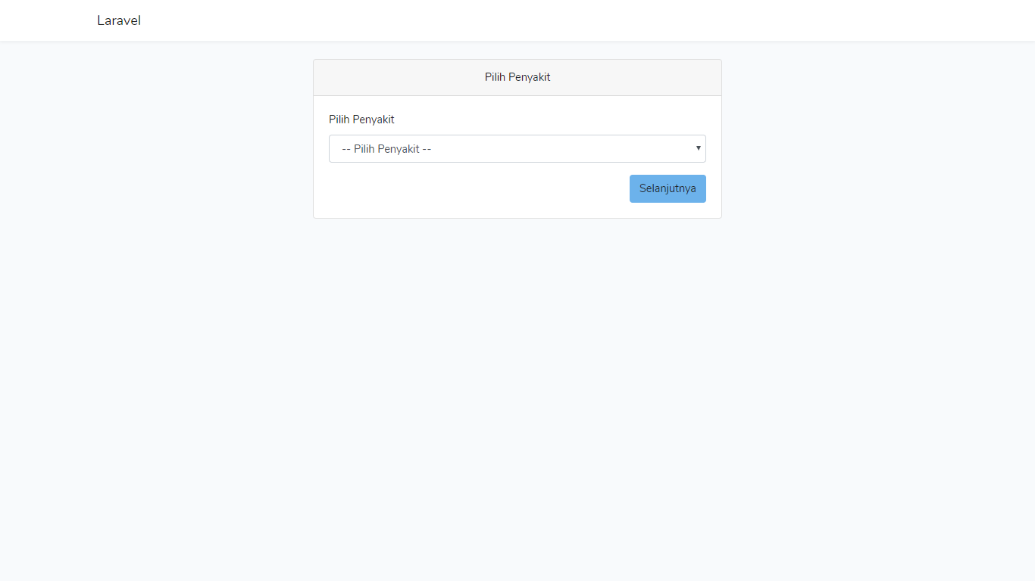

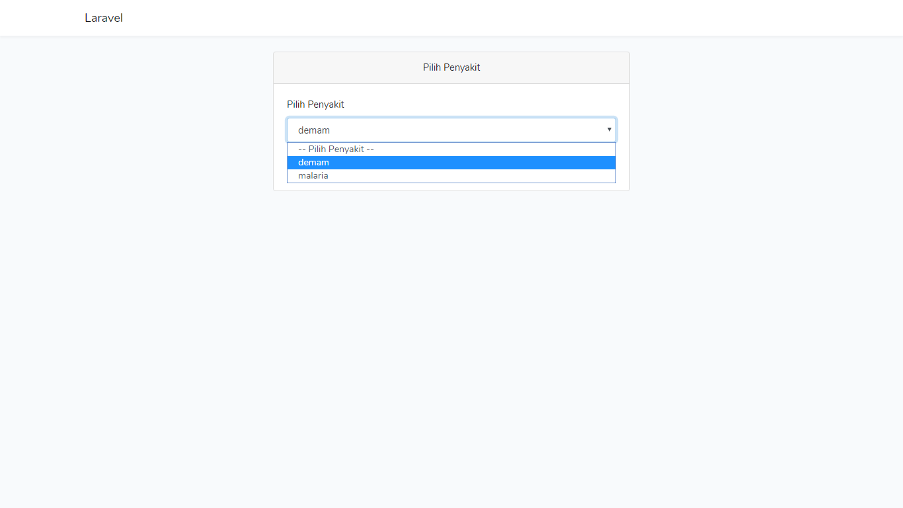

**Halaman test gejala penyakitnya, setelah memilih penyakit:**

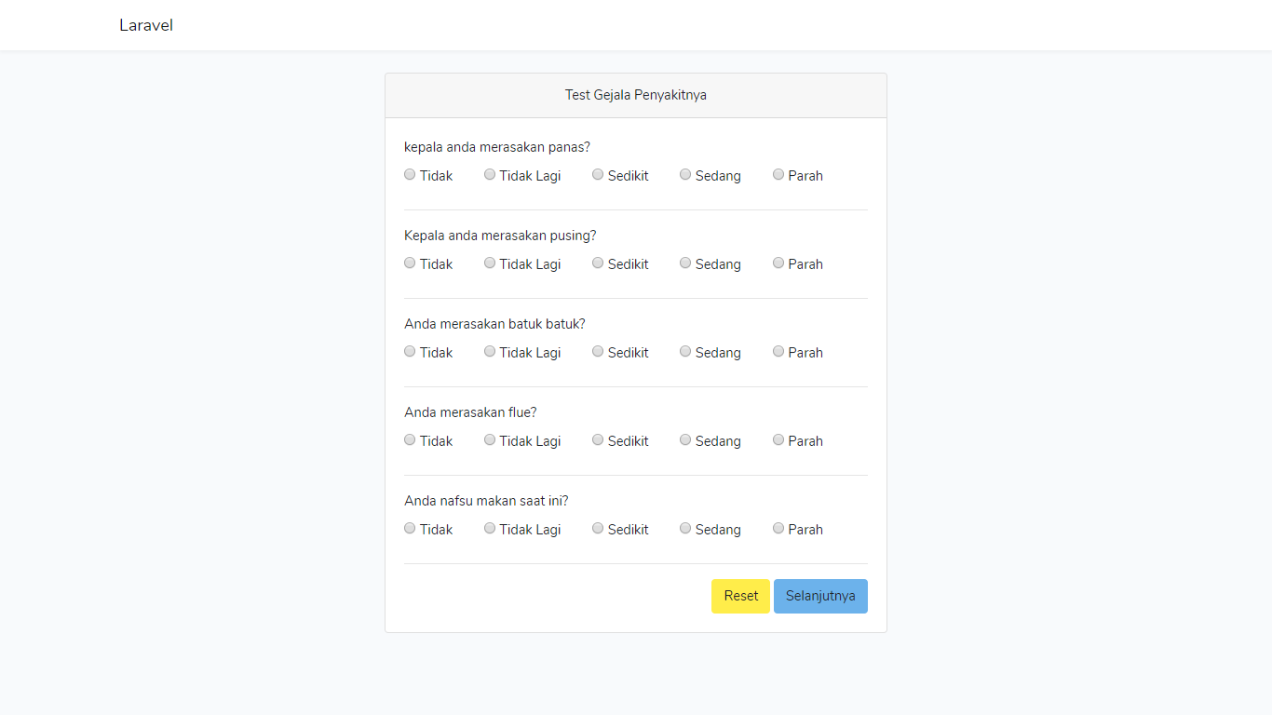

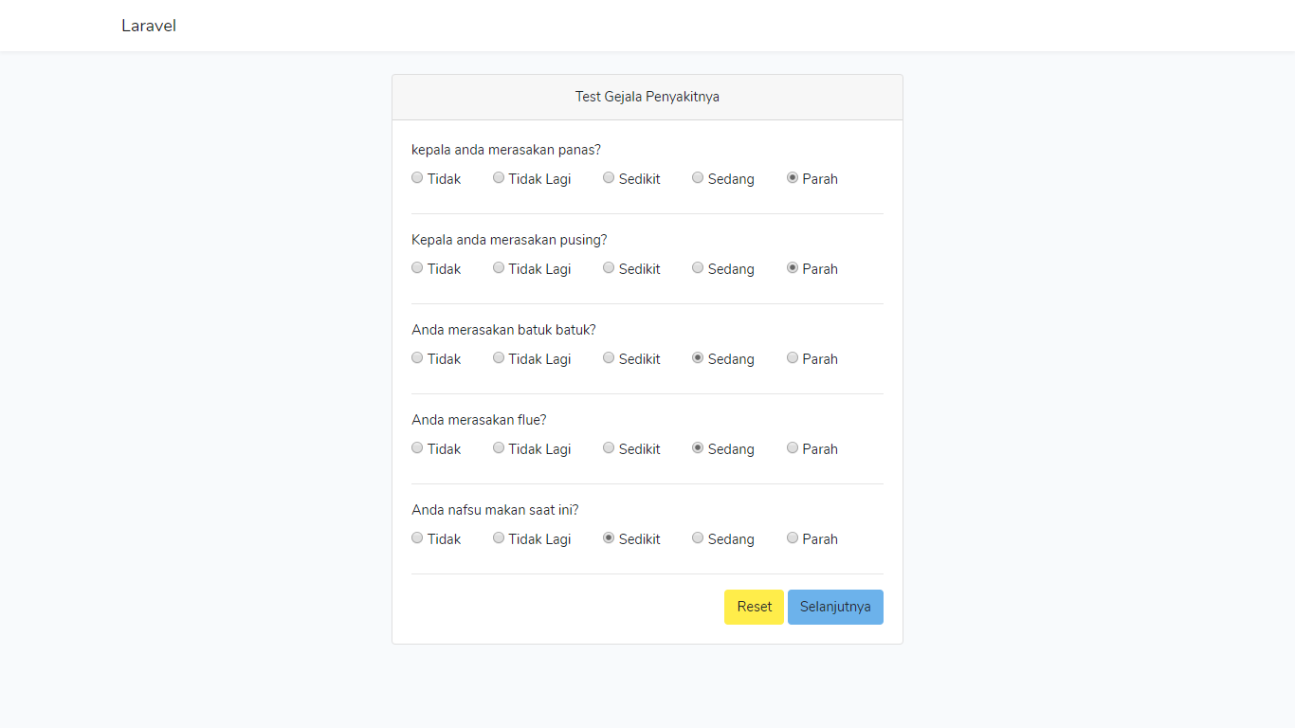

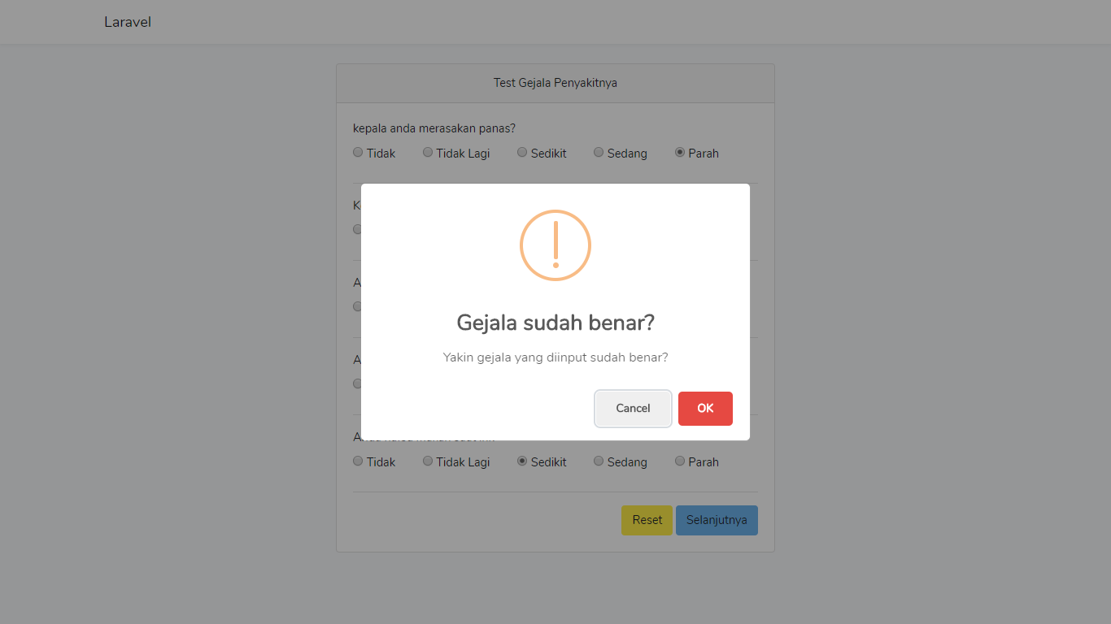**Halaman test gejala penyakitnya jika user mengklik tombol selanjutnya, jika ok maka akan ke halaman selanjutnya**

**Halaman test gejala jika user mengklik tombol reset maka inputan pilih gejala akan tereset ulang.**

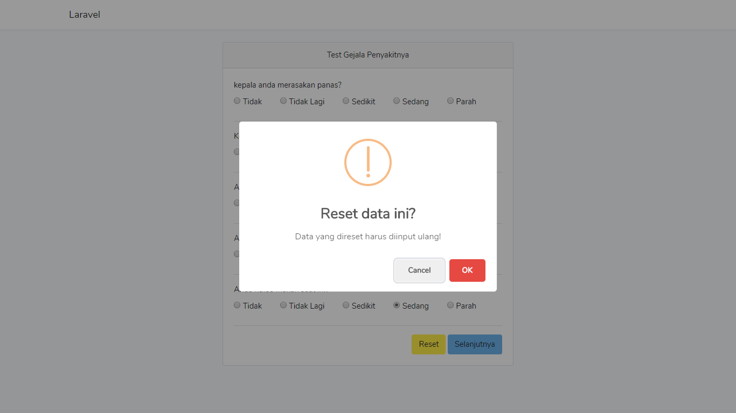

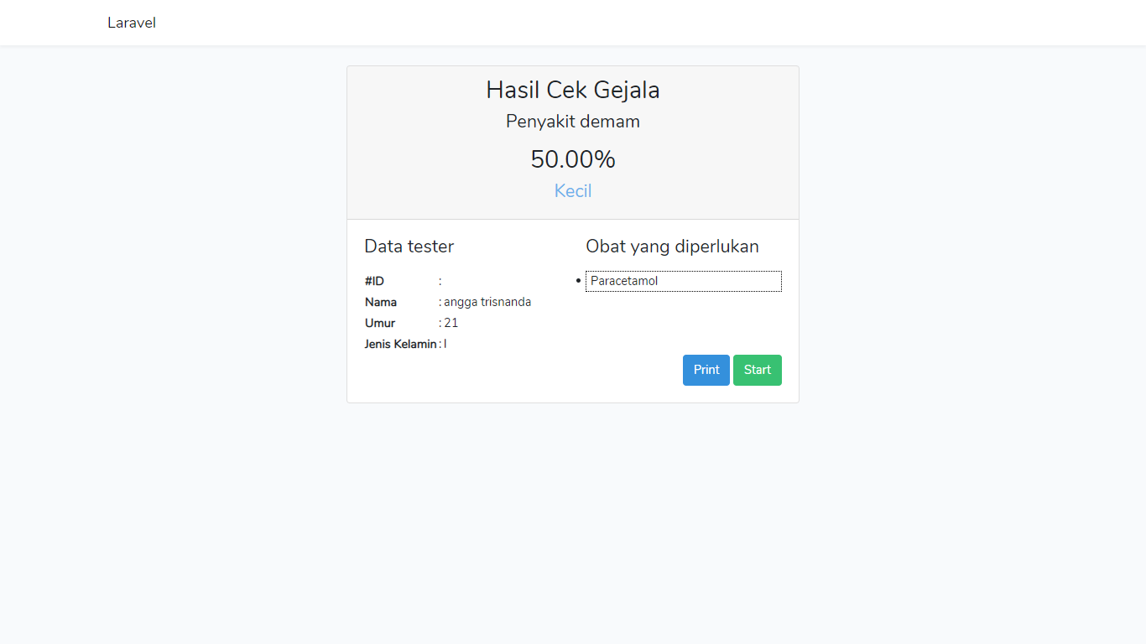**Halaman hasil cek gejala, jika user klik start maka akan mengulangi alur program**

**Halaman print jika user mengklik tombol print,**

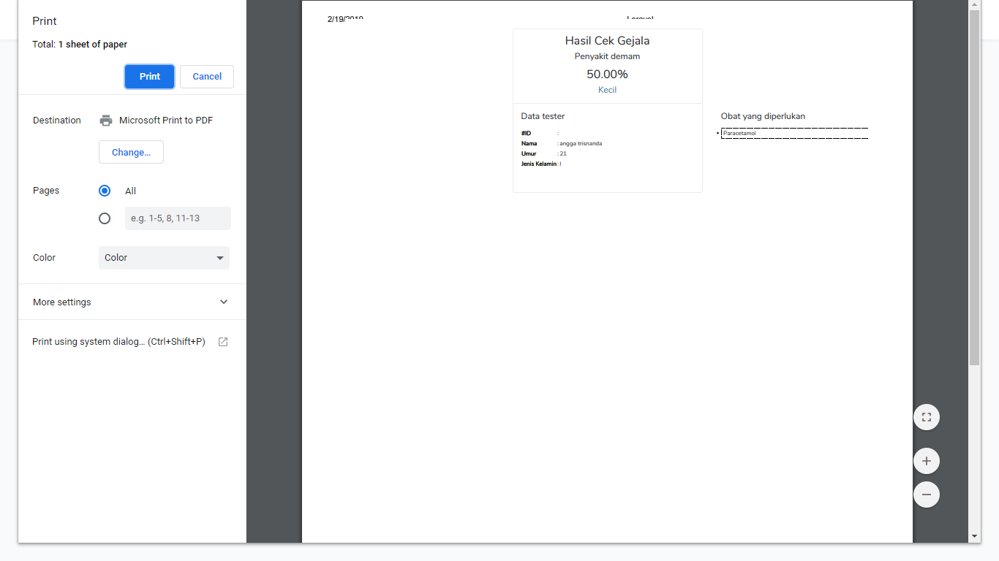

**ROUTE LARAVEL 5.7**

**(routes/web.php)**

<?php

/*

|--------------------------------------------------------------------------

| Web Routes

|--------------------------------------------------------------------------

|

| Here is where you can register web routes for your application. These

| routes are loaded by the RouteServiceProvider within a group which

| contains the "web" middleware group. Now create something great!

|

*/

Route::resource('tester', 'TesterController');

Route::resource('penyakit', 'PenyakitController');

Route::resource('result', 'ResultController');

Route::get('refreshPenyakit', 'PenyakitController@refreshPenyakit')->name('refreshPenyakit');

Route::get('refreshGejala/{penyakit}', 'GejalaController@refreshGejala')->name('refreshGejala');

Route::post('checkValidate', 'TesterController@checkValidate')->name('testerCheckValidate');

Route::get('getPenyakit/{penyakit}', 'PenyakitController@getPenyakit');

Route::get('getObats/{penyakit_id}/{range}/{range_min}', 'ObatController@getObats');

Route::post('tested/store', 'TestedController@store');

Route::get('/', function () {

return view('welcome');

});

Auth::routes();

Route::get('/home', 'HomeController@index')->name('home');

**CONTROLLER**

**(app/Http/Controllers)**

1. GejalaController

<?php

namespace App\Http\Controllers;

use App\Models\Gejala;

use App\Models\Penyakit;

use Illuminate\Http\Request;

class GejalaController extends Controller

{

public function refreshGejala(Penyakit $penyakit)

{

$datas['gejalas'] = Gejala::where('penyakit_id', $penyakit->id)->get();

return response()->json($datas);

}

}

1. ObatController

<?php

namespace App\Http\Controllers;

use App\Models\Obat;

use Illuminate\Http\Request;

class ObatController extends Controller

{

public function getObats($penyakit_id, $range, $range_min)

{

$datas['obats'] = Obat::where('penyakit_id', $penyakit_id)->where('range', '<=', $range)->where('range', '>=', $range_min)->get();

return response()->json($datas);

}

}

1. Penyakitcontroller

<?php

namespace App\Http\Controllers;

use App\Models\Penyakit;

use Illuminate\Http\Request;

class PenyakitController extends Controller

{

public function refreshPenyakit()

{

$datas['penyakits'] = Penyakit::all();

return response()->json($datas);

}

public function getPenyakit(Penyakit $penyakit)

{

$datas['penyakit'] = $penyakit;

return response()->json($datas);

}

}

1. Resultcontroller

<?php

namespace App\Http\Controllers;

use App\Models\Result;

use Illuminate\Http\Request;

class ResultController extends Controller

{

public function store(Request $request)

{

foreach( $request->all() as $id => $jawaban)

{

if ( $id != 'tester_id' && $id != '_token' && $id != 'action' )

{

if ( $jawaban == 'tidak' )

$hasil = 0;

else if ( $jawaban == 'tidak lagi' )

$hasil = .25;

else if ( $jawaban == 'sedikit' )

$hasil = .50;

else if ( $jawaban == 'sedang' )

$hasil = .75;

else if ( $jawaban == 'parah' )

$hasil = 1;

Result::create([

'tester_id' => $request->all()['tester_id'],

'gejala_id' => $id,

'jawaban' => $jawaban,

'hasil' => $hasil

]);

}

}

}

}

1. TestedController

<?php

namespace App\Http\Controllers;

use App\Models\Tested;

use App\Models\Tester;

use Illuminate\Http\Request;

class TestedController extends Controller

{

public function store(Request $request)

{

$testerCreate = Tester::create([

'nama' => $request->nama,

'umur' => $request->umur,

'jenis_kelamin' => $request->jenis_kelamin

]);

$testerCreate->save();

$testerId = $testerCreate->id;

Tested::create([

'tester_id' => $testerId,

'hasil' => $request->range,

'keterangan' => $request->keterangan

]);

return response()->json(['id' => $testerId]);

}

}

1. TesterController

<?php

namespace App\Http\Controllers;

use App\Models\Tester;

use Illuminate\Http\Request;

class TesterController extends Controller

{

public function checkValidate(Request $request)

{

$this->validate($request, [

'nama' => 'required|min:3|max:50',

'umur' => 'required|numeric|max:200',

'jenis_kelamin' => 'required|in:l,p'

]);

return response()->json($request->all());

}

}

**VIEW (public/views)**

**Gejala.blade.php**

<div class="container" ng-controller='GejalaController'>

<div class="row justify-content-center">

<div class="col-md-6">

<div class="card">

<div class="card-header text-center">Test Gejala Penyakitnya</div>

<div class="card-body">

<form name='gejalaResult' id='gejalaResult'>

<input type='hidden' name='action' value='#!/penyakit/gejala/{{ penyakit_id }}/result' />

<div class='form-group'>

<div ng-repeat = 'gejala in gejalas'>

<label for='penyakit_id'>{{ gejala.keterangan }}</label>

<div class='d-flex justify-content-between mr-5'>

<label>

<input value='tidak' type='radio' name='{{ gejala.id }}' required> Tidak

</label>

<label>

<input value='tidak lagi' type='radio' name='{{ gejala.id }}'> Tidak Lagi

</label>

<label>

<input value='sedikit' type='radio' name='{{ gejala.id }}'> Sedikit

</label>

<label>

<input value='sedang' type='radio' name='{{ gejala.id }}'> Sedang

</label>

<label>

<input value='parah' type='radio' name='{{ gejala.id }}'> Parah

</label>

</div>

<hr>

</div>

</div>

<div class="form-group">

<span class='float-right'>

<button type='reset' class="reset btn btn-warning">

Reset

</button>

<button type='submit' class="btn btn-info">

Selanjutnya

</button>

</span>

</div>

</form>

</div>

</div>

</div>

</div>

</div>

**GejalaResult.blade.php**

<div class="container" ng-controller='GejalaResultController'>

<div class="row justify-content-center">

<div class="col-md-6">

<div class="card">

<div class="card-header text-center">

<h2>Hasil Cek Gejala</h2>

<h4>Penyakit {{ penyakit.nama }}</h4>

<p>

<h2>{{ range }}%</h2>

<h4>

<span ng-if='tingkat == "Normal"'>

<span class='text-success'>{{ tingkat }}</span>

</span>

<span ng-if='tingkat == "Awal"'>

<span class='text-secondary'>{{ tingkat }}</span>

</span>

<span ng-if='tingkat == "Kecil"'>

<span class='text-info'>{{ tingkat }}</span>

</span>

<span ng-if='tingkat == "Sedang"'>

<span class='text-warning'>{{ tingkat }}</span>

</span>

<span ng-if='tingkat == "Parah"'>

<span class='text-danger'>{{ tingkat }}</span>

</span>

</h4>

</div>

<div class="card-body container">

<div class='row'>

<div class='col-6'>

<h4>Data tester</h4>

<p>

<table>

<tr>

<th>#ID</th>

<td>:</td>

<td>{{ tester.id }}</td>

</tr>

<tr>

<th>Nama</th>

<td>:</td>

<td>{{ tester.nama }}</td>

</tr>

<tr>

<th>Umur</th>

<td>:</td>

<td>{{ tester.umur }}</td>

</tr>

<tr>

<th>Jenis Kelamin</th>

<td>:</td>

<td>{{ tester.jenis_kelamin }}</td>

</tr>

</table>

</div>

<div class='col-6'>

<h4>Obat yang diperlukan</h4>

<p>

<ul style='border: 1px dotted black; padding: 0 5px;'>

<li ng-repeat='obat in obats'>{{ obat.nama }}</li>

</ul>

</div>

</div>

<div class='row'>

<div class='col-12'>

<span class='float-right'>

<button class='btn btn-primary' onclick=' this.style.display = "none"; print(); this.style.display = "inline-block";'> Print</button>

<a class='btn btn-success' href='#!/'> Start</a>

</span>

</div>

</div>

</div>

</div>

</div>

</div>

</div>

**PilihPenyakit.blade.php**

<div class="container" ng-controller='PilihPenyakitController'>

<div class="row justify-content-center">

<div class="col-md-6">

<div class="card">

<div class="card-header text-center">Pilih Penyakit</div>

<div class="card-body">

<form name='pilihPenyakit' id='pilihPenyakit'>

<div class='form-group'>

<label for='penyakit_id'>Pilih Penyakit</label>

<select id='penyakit_id' class='form-control' name='penyakit_id'>

<option value=''>-- Pilih Penyakit --</option>

<option ng-repeat='penyakit in penyakits' value='{{ penyakit.id }}'>{{ penyakit.nama }}</option>

</select>

<ul ng-if='testersCreateErrors !== null'>

<li ng-repeat='error in pilihPenyakitErrors.errors.penyakit_id' ng-bind-html-unsafe='error'>{{ error }}</li>

</ul>

</div>

<div class="form-group">

<span class='float-right'>

<button type='submit' class="btn btn-info">

Selanjutnya

</button>

</span>

</div>

</form>

</div>

</div>

</div>

</div>

</div>

**Welcome.blade.php**

<div class="container" ng-controller='RegisterTesterController'>

<div class="row justify-content-center">

<div class="col-md-6">

<div class="card">

<div class="card-header text-center">Register Tester</div>

<div class="card-body">

<form action='#!pilihPenyakit' name='testerCreate' id='testerCreate'>

<div class='form-group'>

<label for='nama'>Nama</label>

<input ng-model='nama' id='nama' class='form-control' name='nama' required/>

<ul ng-if='testersCreateErrors.errors !== null'>

<li ng-repeat='error in testersCreateErrors.errors.nama' ng-bind-html-unsafe='error'>

<span class='text-danger'>{{ error }}</span>

</li>

</ul>

</div>

<div class='form-group'>

<label for='umur'>Umur</label>

<input type='number' min='1' max='100' ng-model='umur' id='umur' class='form-control' name='umur' required/>

<ul ng-if='testersCreateErrors.errors !== null'>

<li ng-repeat='error in testersCreateErrors.errors.umur' ng-bind-html-unsafe='error'>

<span class='text-danger'>{{ error }}</span>

</li>

</ul>

</div>

<div class='form-group'>

<label for='jenis_kelamin'>Jenis Kelamin</label>

<select ng-model='jenis_kelamin' id='jenis_kelamin' class='form-control' name='jenis_kelamin' required>

<option value=''>-- Pilih Jenis Kelamin --</option>

<option value='l'>Laki - Laki</option>

<option value='p'>Perempuan</option>

</select>

<ul ng-if='testersCreateErrors.errors !== null'>

<li ng-repeat='error in testersCreateErrors.errors.jenis_kelamin' ng-bind-html-unsafe='error'>

<span class='text-danger'>{{ error }}</span>

</li>

</ul>

</div>

<div class="form-group">

<span class='float-right'>

<button type='reset' class="reset btn btn-warning">

Reset

</button>

<button type='submit' class="btn btn-info">

Selanjutnya

</button>

</span>

</div>

</form>

</div>

</div>

</div>

</div>

</div>